

INAF - LBT OBSERVING PROGRAMS
DDT Request

1. Title
2. Abstract

3. Number of requested hours per instrument

LBC | LUCI | MODS | LBTI | PEPSI | TOTAL

4. Principal investigator |  | 5. Co-investigators (name and institution)
Name:
Institute:
Address:
e-mail:
Phone:

6. Report about previous use of LBT time
7a. If this proposal is a part of a PhD thesis, write here the name of the student, the thesis title and briefly describe the relevance of these observations for the thesis goals.
7b. Is this, or a similar application submitted to other time allocation committees (e.g. ESO, TNG-CAT, ITP)? If yes, please specify which and explain if and why the proposals should be considered complementary.
8. Description of the programme (2 pages + ≤1 page for references, tables and figures)
9. Observational strategy and justification of instrumental setup and of requested time (net exposition time WITHOUT overheads), including night time calibration.
10. Requested instrument(s) setup for each run
ID | Target | RA(J2000) | DEC(J2000) | Inst. Mode | Config | T.exp  [h] | Seeing  [a.sec] | Air  mass | Moon/  Sky | ToO
A | GRB-xxxxxx | 00 00 00.00 | +32 00 55.00 | LUCI-LS-SL | N1.80/0.75/G200/zj | 2 | 1 | 1.5 | b/cle | N
B | M49 | 12 30 00.97 | +07 55 45.7 | MODS-MOS | D-Grating/Custom | 2.5 | 1.5 | 1.2 | d/cle | N

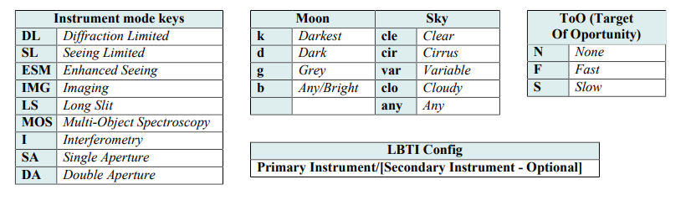
11. Strategy and needs for calibration.

